# Attendance Marking for Students in Haveloc

Only Active Attendance will be shown here, to get more information go to Tracker Tab.

1. **Go To Attendance Tab**

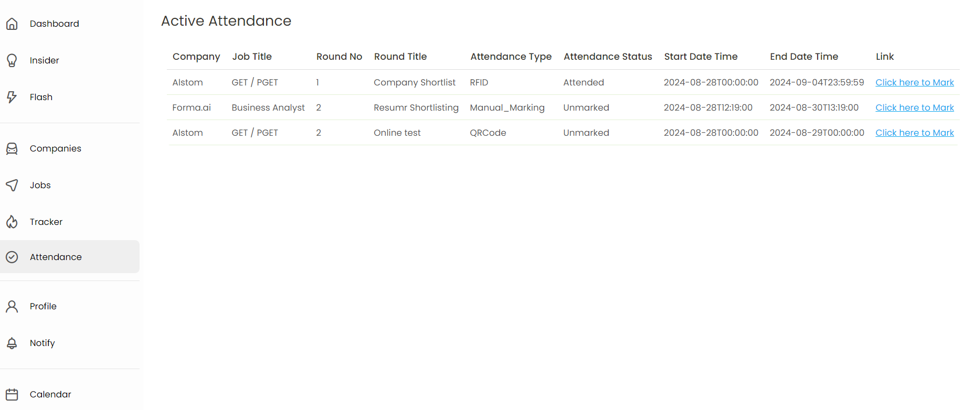

1. Click on “Click here to Mark” 🡪 For marking attendance



1. Check the type of Attendance – RFID, QR Code, Manual Marking.
   1. For RFID – Student has to bring their RFID Card near to RFID Scanner Location
   2. QR Code – Student can scan or Enter the QR Code which is shown in the Venue.
   3. Manual Marking – Student has option to mark Attended or Absent or Skipped by their own.

**RFID:**

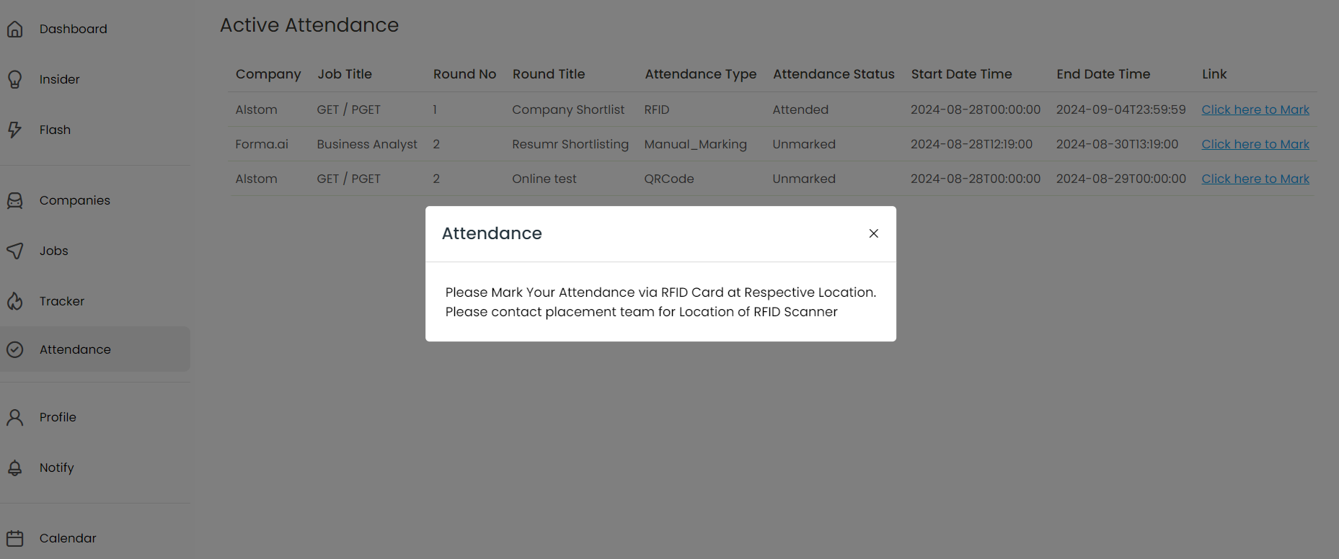

**QR Code:**

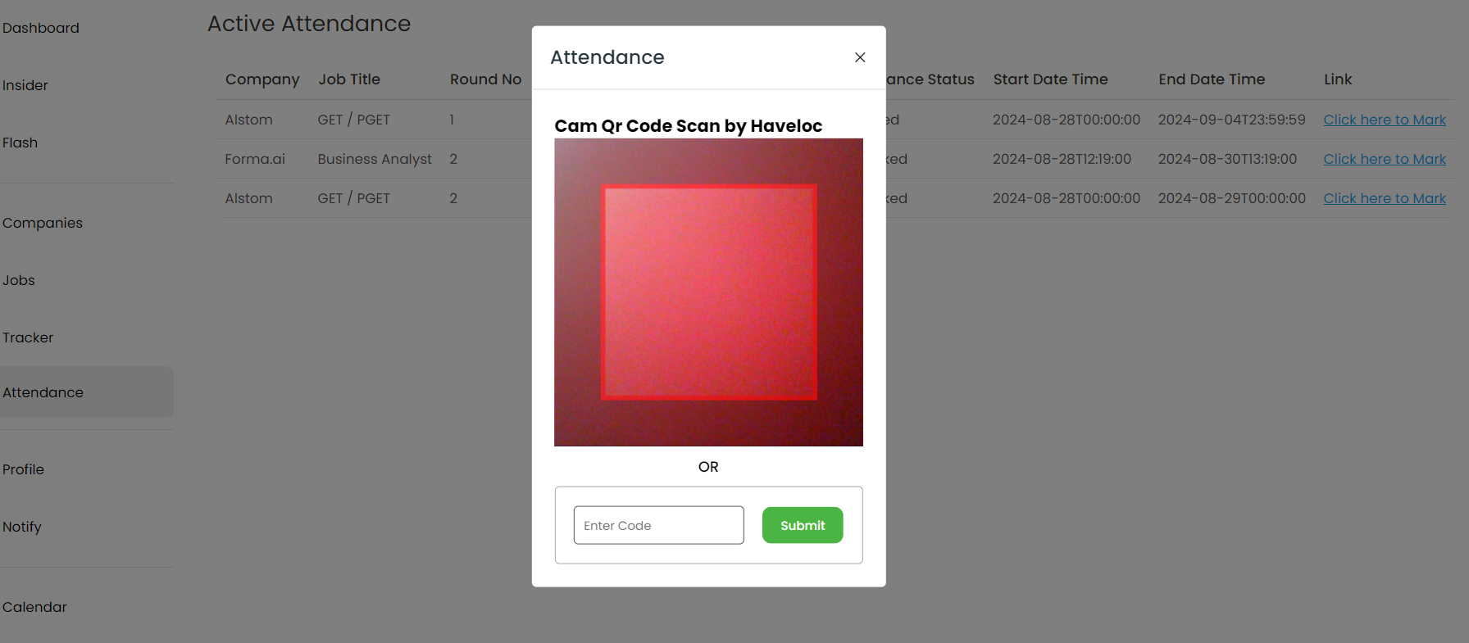

**Manual: (make sure, enter confirm text shown)**

